ASSIGNMENT 2

• Connect to the Store Sales Data and do the following:

- − Remove all the blank rows.

− Update the column header if they are not updated

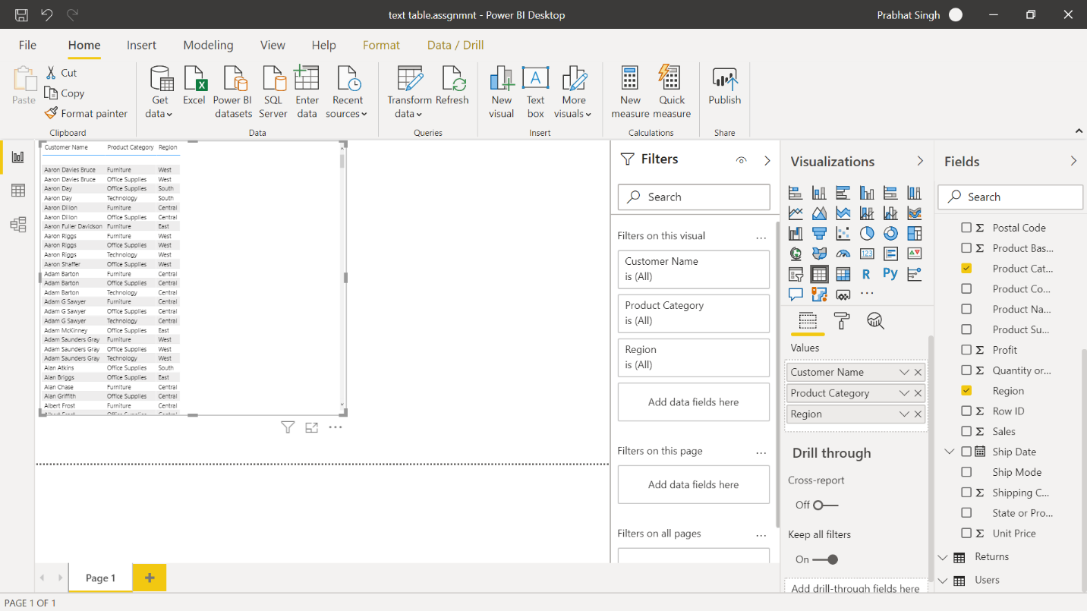 − Create a text table and show the sales in terms of o Customers o Product Category o Regions

• Create a Donut Chart showing sales in terms of Product category

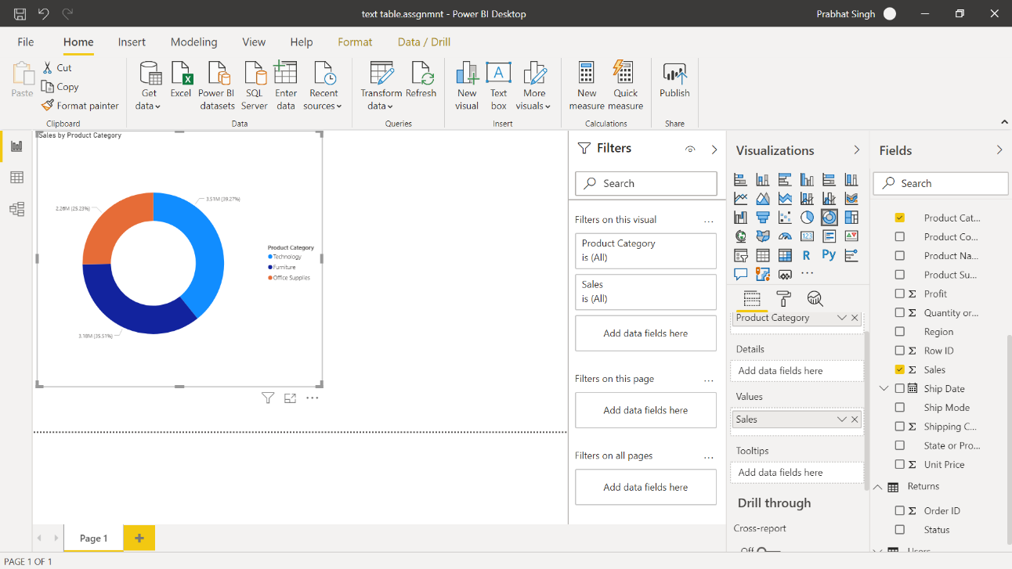

• Create a line and Clustered Column Chart showing the Sales and Discount as per the State or Province − Format the bars and line with different colors

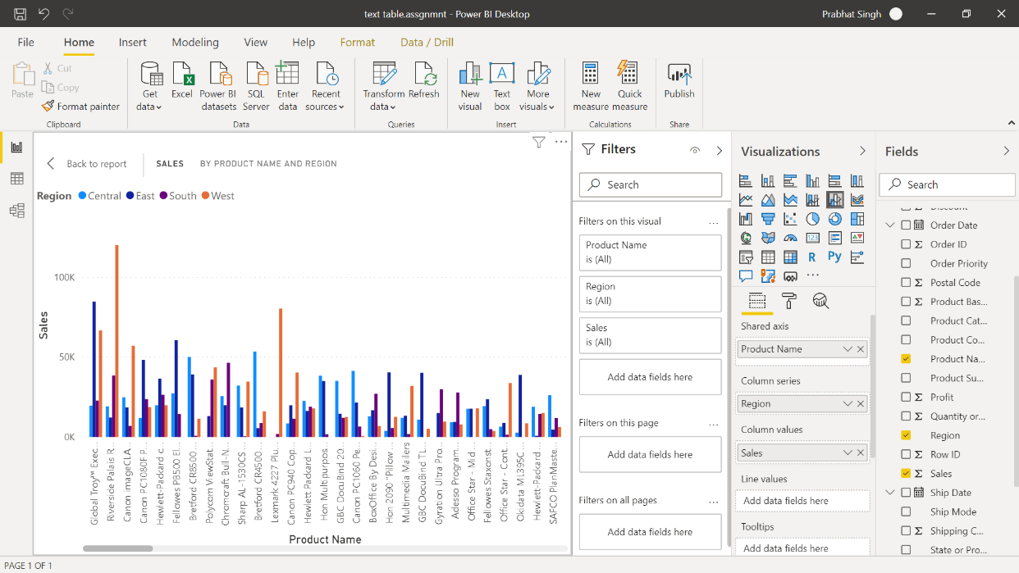 − Which state has the highest sales in terms Technology

• Create a Slicer and show the regions in dropdown. See how all the visuals mentioned above behaving when a particular region is selected.

